👋 Hi everyone, Hamza.
Welcome to Edition #30 of a newsletter that 15,000+ people around the world actually look forward to reading.
We’re living through a strange moment: the internet is drowning in polished AI noise that says nothing.
This isn’t that. You’ll find raw, honest, human insight here, the kind that challenges how you think, not just what you know. Thanks for being part of a community that still values depth over volume.
🎓 Want to up skill in AI?
- Join the next cohort of my Agent Engineering Bootcamp (Developers Edition) April 8
- Watch the free 4-session Agent Bootcamp playlist on YouTube

ReAct vs Automation Agents: Key AI Differences
Artificial intelligence has evolved from simple task-executing systems to sophisticated reasoning frameworks. While traditional automation agents work well for routine tasks, ReAct agents bring something new. They combine thinking with action. They adapt on the fly.
You need to understand these differences if you want AI that handles complex problems. ReAct agents don't just follow scripts. They reason through challenges, adjust to changes, and show you how they make decisions.
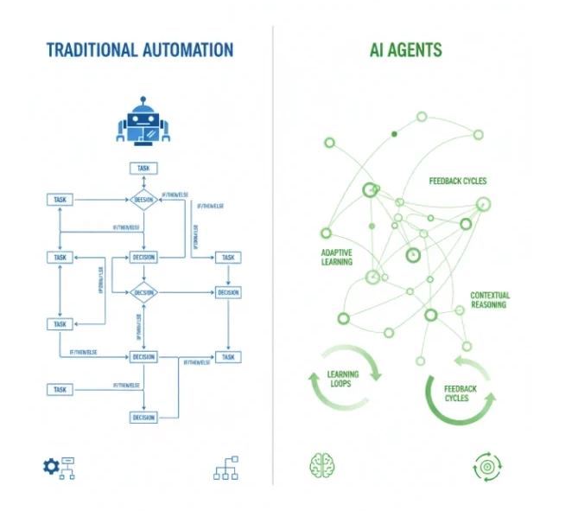
Source: https://diffstudy.com/ai-agents-vs-traditional-automation/

What is a ReAct Agent in AI?

Understanding ReAct Agent Architecture and Core Principles
ReAct agents mark a shift in AI design. They move beyond simple task execution to reasoning. The ReAct framework combines reasoning and acting in one system. AI agents think before they move. They use large language models (LLMs) to create transparent decision-making processes.
A ReAct agent runs on a continuous cycle: observe, think, act. When you give these agents a task, they analyze the situation first. They form a strategy. Then they execute based on logic.
The architecture includes:
- An LLM-powered reasoning engine
- A function calling system for tool integration
- A memory system for maintaining context
These parts work together. The agent adapts and learns from each interaction.
ReAct agents interpret ambiguous instructions. They consider multiple paths forward. They pick the best approach based on context. This flexibility comes from metacognition. They think about their own thinking.
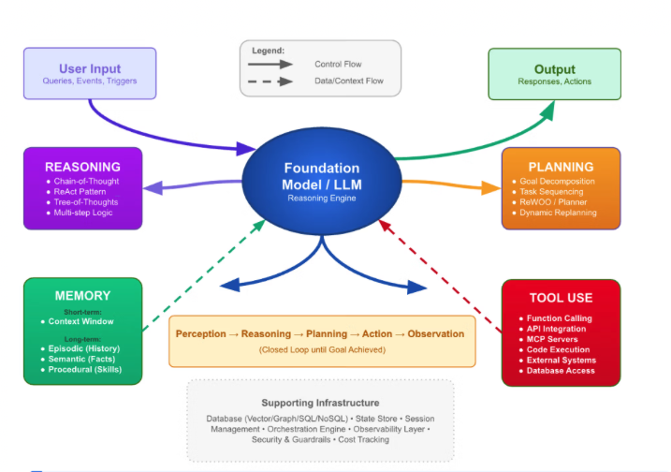
Source: https://unstructured.io/blog/defining-the-autonomous-enterprise-reasoning-memory-and-the-core-capabilities-of-agentic-ai

The Role of Chain-of-Thought Reasoning in ReAct Frameworks
Chain-of-thought reasoning powers ReAct agents. These agents break down complex problems into logical steps. They show their work. You see how they reach decisions.
ReAct agents think before each action. They consider different approaches. They evaluate outcomes. They select the best path. This transforms AI from a reactive tool into a problem-solving partner.
The process works through structured prompts. The agent examines the current state. It identifies relevant information. It considers available tools. It makes a plan before moving forward.
When these agents hit obstacles, they reassess. They modify their approach. They find alternative solutions while staying focused on your goal.
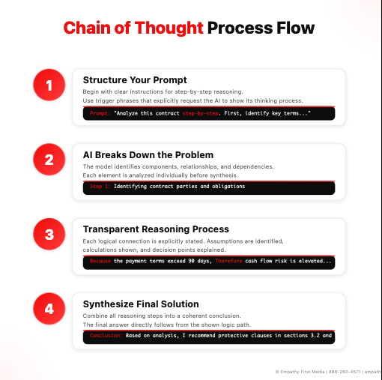
Source: https://empathyfirstmedia.com/chain-of-thought-prompting/

Traditional Automation Agents: Foundation and Limitations

How Automation Agents Process Tasks and Execute Commands
Traditional automation agents work differently. They rely on predefined workflows and rule-based decision trees. When they receive input, they match it against programmed criteria. Then they execute the corresponding action. No deliberation. No context analysis.
These agents excel at routine, well-defined tasks. They handle high volumes of standardized operations:
- Data entry
- File transfers
- Simple API calls
They follow instructions with perfect consistency. This makes them ideal for repetitive business processes.
But this rigidity becomes a problem with novel situations. Automation agents don't adapt based on context. They don't learn from past interactions. They work within the boundaries of their programming.
When automation agents face scenarios outside their parameters, they fail or require manual intervention.
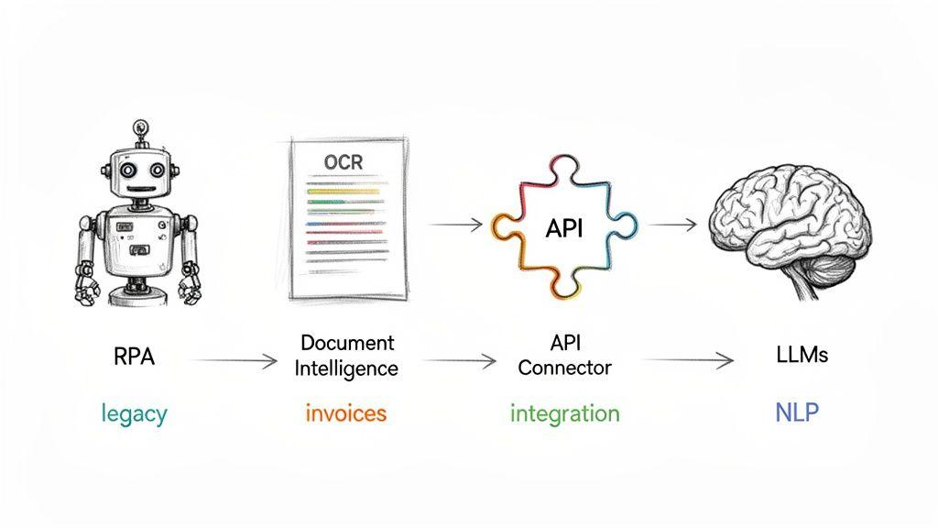
Source: https://www.redbricklabs.io/blog/how-to-automate-data-entry

Static Rule Systems vs Dynamic Problem-Solving Approaches
Traditional automation agents use static rule systems. They operate through if-then logic. This ensures predictable behavior but limits their ability to handle unexpected scenarios.
Static systems require comprehensive pre-planning. Developers must program every decision path. They create extensive decision trees to cover all possible use cases. This gets exponentially complex as variables increase.
Dynamic problem-solving works differently. AI systems generate novel solutions based on reasoning and context. ReAct agents analyze unfamiliar situations. They draw from their training knowledge. They formulate appropriate responses without explicit programming for every scenario.
Static systems struggle in high-variability environments. While automation agents work well in stable processes, they fail when business rules change or new exceptions arise.
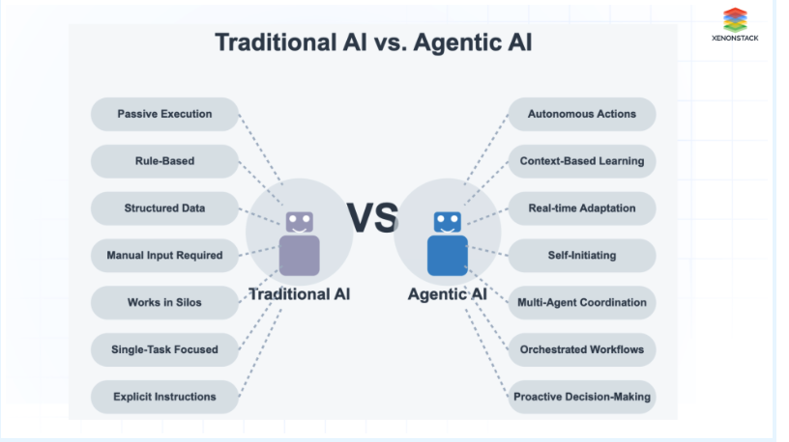
Source: https://www.xenonstack.com/blog/agentic-ai-for-data-management?utm_source=chatgpt.com

Core Differences Between ReAct Agents and Automation Agents

Reasoning Frameworks vs Predefined Workflows
The most fundamental difference lies in decision-making. ReAct agents think through problems systematically. Automation agents follow predefined workflows without thinking.
ReAct agents start each task with analysis. They examine the current situation. They identify relevant context. They formulate strategy. The process involves:
- Understanding your intent
- Evaluating available tools and resources
- Anticipating obstacles
- Developing contingency plans
Automation agents execute predetermined sequences based on trigger conditions. When criteria are met, they follow scripted pathways. No broader context. No alternative approaches.
ReAct agents handle ambiguous instructions and incomplete information. They ask clarifying questions. They request additional information when needed. They adjust based on feedback.
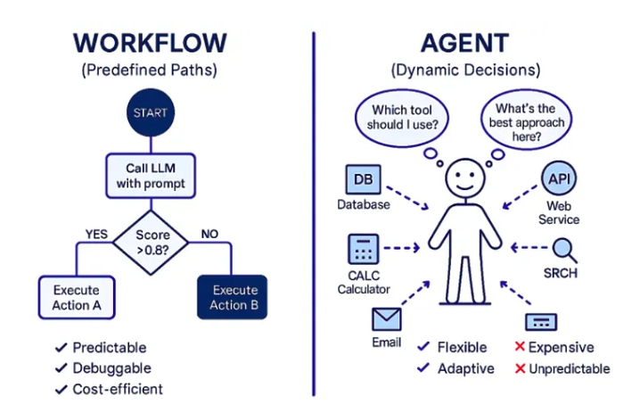
Source: https://medium.com/@neeldevenshah/ai-workflows-vs-ai-agents-vs-multi-agentic-systems-a-comprehensive-guide-f945d5e2e991

LLM Integration and Natural Language Processing Capabilities
Large language models power ReAct agents. They provide sophisticated natural language understanding that automation agents lack. This lets ReAct agents interpret nuanced instructions, understand context and intent, and communicate naturally.
ReAct agents go beyond simple command recognition. They understand implicit requirements. They interpret ambiguous requests. They anticipate your needs based on conversational context. They remember previous conversations and build on established context.
Automation agents need structured inputs. They use predefined commands or simple pattern matching. They don't interpret natural language well. You must communicate through specific interfaces or command structures.
LLM-powered ReAct agents explain their actions. They provide status updates in natural language. They discuss their decision-making process. This builds trust and creates collaboration.

Function Calling and Tool Integration Mechanisms
ReAct agents show superior flexibility in tool integration through dynamic function calling. They assess available tools. They select appropriate combinations based on task requirements. They adapt their tool usage throughout execution.
When faced with a complex task, a ReAct agent evaluates its toolkit. It determines the most effective combination of functions. The agent switches between tools. It chains multiple functions together. It discovers novel tool combinations.
Automation agents use predetermined tool sequences defined during initial configuration. They don't deviate from established patterns. If the predefined sequence hits an error, the automation agent often fails or needs manual intervention.
ReAct agents support error handling and recovery. When a tool fails, the agent analyzes the failure. It selects alternative approaches. It continues working toward the objective.
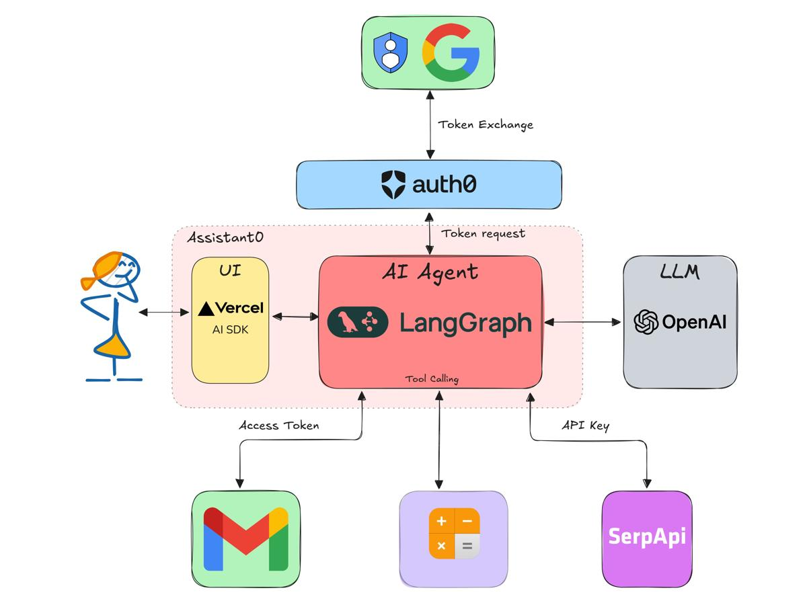
Source: https://auth0.com/blog/genai-tool-calling-build-agent-that-calls-calender-with-langgraph-nextjs/

How ReAct Agents Leverage LLMs for Enhanced Decision-Making

Natural Language Understanding and Context Interpretation
ReAct agents harness LLMs to achieve unprecedented natural language understanding. They comprehend subtle nuances in human communication. They pick up on implied meanings, emotional context, and situational awareness.
The LLM integration lets ReAct agents parse complex instructions with multiple objectives. For example, when you request "Help me prepare for tomorrow's presentation by gathering relevant data and creating visual summaries," the agent understands this involves research, data analysis, and visualization tasks.
Context interpretation extends beyond individual requests. ReAct agents maintain understanding across multiple interactions. They build a comprehensive picture of your preferences, project requirements, and ongoing objectives.
These agents ask clarifying questions when faced with ambiguous instructions. Rather than making assumptions or failing, they engage in dialogue to ensure they understand your intent.
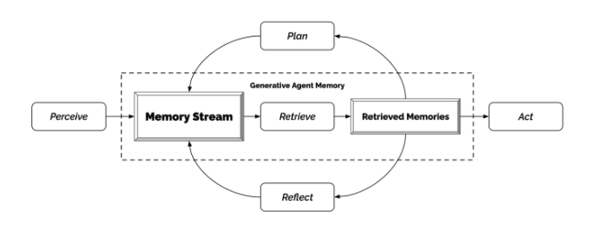
Source: https://www.lesswrong.com/posts/43C3igfmMrE9Qoyfe/scaffolded-llms-as-natural-language-computers

Iterative Reasoning and Multi-Step Problem Solving
ReAct agents approach complex tasks through systematic decomposition. They break down large objectives into manageable sub-problems. They address these sequentially while maintaining awareness of the overall goal.
During each iteration, ReAct agents evaluate their progress. They assess the effectiveness of their current approach. They make adjustments as needed.
The multi-step problem-solving approach involves:
- Initial analysis and planning
- Incremental execution with progress monitoring
- Intermediate result evaluation
- Strategy refinement
At each stage, the agent considers resource constraints, time limitations, and quality requirements.
This methodology proves valuable for research tasks, creative projects, and complex analytical work. ReAct agents explore different strategies. They learn from intermediate results. They converge on effective solutions through systematic experimentation.
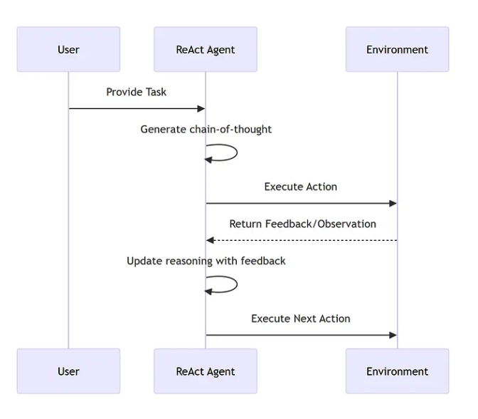
Source: https://ai.plainenglish.io/agents-react-vs-coact-d44ada0dd103

Self-Correction and Adaptive Learning Mechanisms
ReAct agents incorporate self-correction mechanisms. They identify errors. They analyze failure modes. They implement corrective measures on their own.
The self-correction process starts with continuous monitoring of action outcomes. When a ReAct agent detects unexpected results or errors, it initiates a diagnostic sequence. This analysis considers input validation, tool availability, execution environment, and logical consistency.
Once the agent identifies the error source, it develops alternative strategies. This may involve:
- Selecting different tools
- Modifying parameters
- Breaking down the task into smaller steps
- Seeking additional information from you
Adaptive learning mechanisms enable ReAct agents to improve performance over time. While these agents don't retain information between sessions for privacy reasons, they optimize their approach within a single conversation based on accumulated experience.
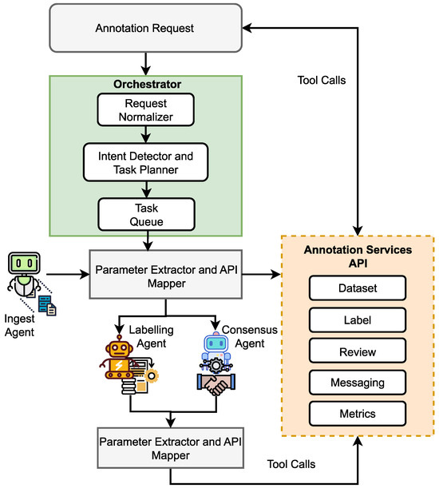
Source: https://www.mdpi.com/1999-5903/17/8/353

Real-World Applications and Use Cases

Customer Service and Support Automation
ReAct agents have transformed customer service by providing intelligent, context-aware support. They adapt to individual customer needs and complex problem scenarios. Unlike traditional chatbots with predefined decision trees, ReAct agents understand nuanced inquiries. They gather relevant information from multiple sources. They provide personalized solutions.
When a customer describes an issue, the agent analyzes the problem. It identifies relevant product information. It checks account history. It formulates a comprehensive response strategy. The agent escalates issues appropriately and coordinates with multiple departments.
Case Study: A telecommunications company implemented a ReAct agent for technical support. Results:
- 45% reduction in average resolution time
- Customer satisfaction improved from 3.2 to 4.6 out of 5
- $2.8 million annual savings in support costs
The agent diagnosed network connectivity issues. It guided customers through troubleshooting. It automatically provisioned service adjustments when technical solutions weren't sufficient.
The transparency of ReAct agents' reasoning process enables better quality assurance. Supervisors review the agent's decision-making process. They identify areas for improvement. They understand the logic behind specific recommendations.

Research and Data Analysis Tasks
Research applications showcase the power of ReAct agents. They synthesize information from multiple sources. They reason through complex data relationships. They generate comprehensive analytical insights.
A research-focused ReAct agent starts by understanding the research question. It develops a search strategy. It gathers information from various databases and sources. It evaluates source credibility. It identifies patterns and trends. It synthesizes findings into coherent conclusions.
For market research applications, ReAct agents monitor industry trends. They analyze competitor activities. They gather consumer sentiment data. They generate strategic insights. The agents access real-time information through web searches. They analyze social media trends. They review financial reports. They synthesize this information into actionable business intelligence.
Case Study: A pharmaceutical research firm deployed ReAct agents for literature review and competitive analysis. Results:
- Research cycle time reduced from 6 weeks to 10 days
- 40% more relevant studies identified
The agents cross-referenced findings across multiple databases. They identified contradictory results. They flagged potential research gaps. Researchers focused on higher-level analysis and hypothesis development.
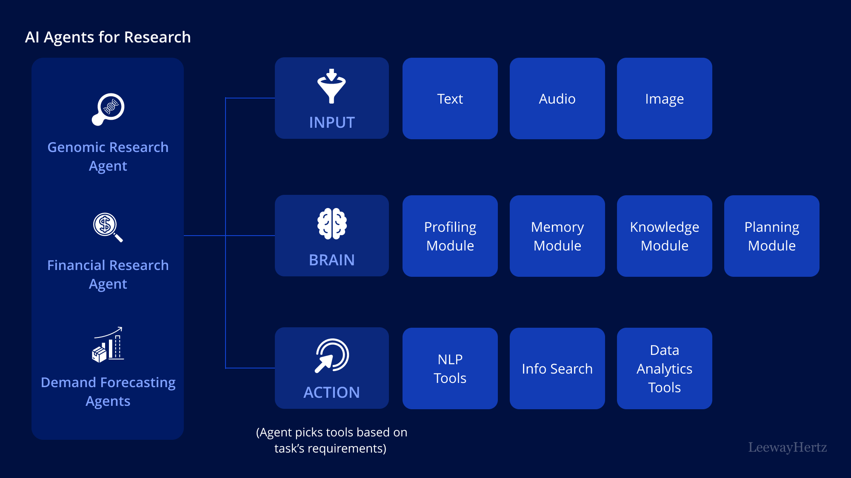
Source: https://www.leewayhertz.com/ai-agents-in-research/

Content Creation and Creative Tasks
Content creation represents an emerging frontier for ReAct agents. Their reasoning capabilities enable sophisticated creative processes beyond simple template filling.
These agents understand creative briefs. They research relevant topics. They develop content strategies. They produce engaging materials tailored to specific audiences and objectives.
The creative process involves:
- Understanding the target audience
- Analyzing successful content in the relevant domain
- Identifying key messages and themes
- Developing a content structure
- Iteratively refining the output based on quality criteria
For technical writing applications, ReAct agents research complex topics. They interview subject matter experts through structured questioning. They organize information logically. They present technical concepts in accessible language.
Case Study: A software documentation team utilized ReAct agents to create API documentation and user guides. Results:
- 60% improvement in documentation quality scores
- 35% reduction in writing time
The agents analyzed code repositories. They extracted relevant information. They created examples. They structured content based on user personas and use cases. Technical writers focused on strategic information architecture and user experience design.
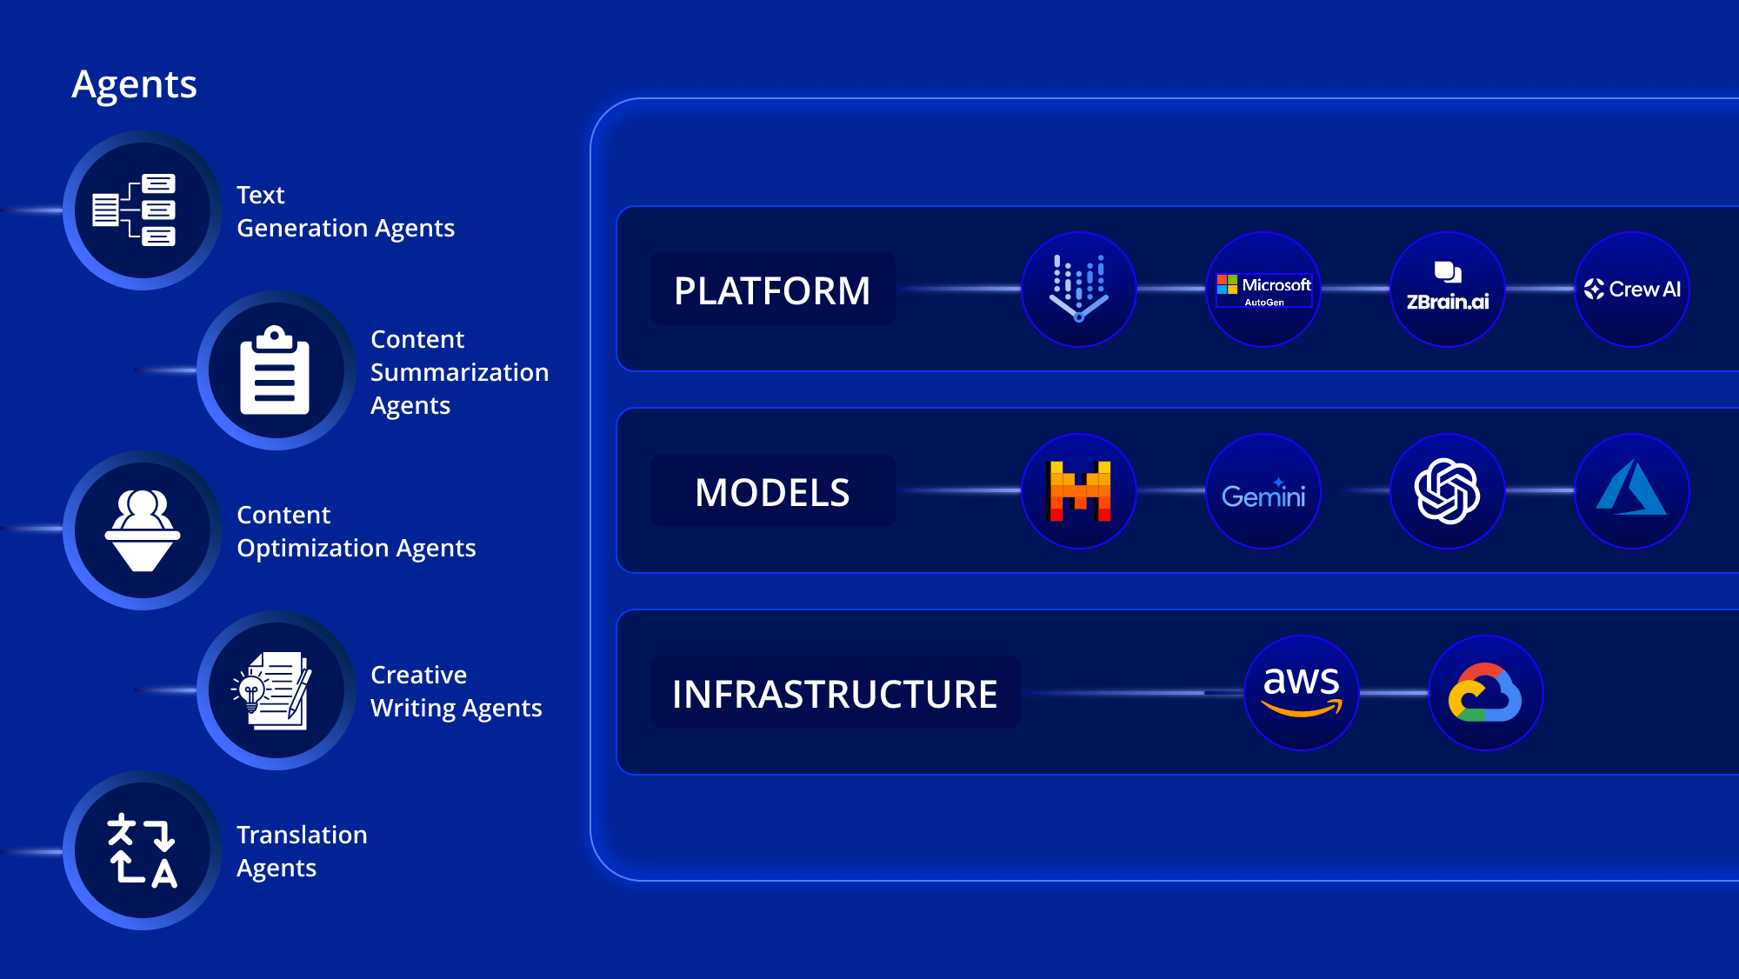
Source: https://www.leewayhertz.com/ai-agent-for-content-generation/

Business Process Automation and Workflow Management
ReAct agents are transforming business process automation by introducing intelligent decision-making and adaptive workflow management. These agents handle complex business processes with multiple stakeholders, conditional logic, and dynamic requirements.
ReAct agents manage end-to-end business processes:
- Vendor onboarding
- Project management
- Compliance workflows
The agents understand process requirements. They coordinate with multiple parties. They handle exceptions and edge cases. They ensure compliance with relevant policies and regulations.
For project management applications, ReAct agents monitor project progress. They identify potential risks and delays. They coordinate team communications. They recommend corrective actions.
Case Study: A manufacturing company implemented ReAct agents for supply chain management. Results:
- 25% reduction in procurement cycle time
- 15% cost savings through intelligent vendor selection and negotiation support
The agents analyzed supplier performance data. They evaluated risk factors. They negotiated terms within predefined parameters. They adapted procurement strategies based on market conditions and inventory requirements.
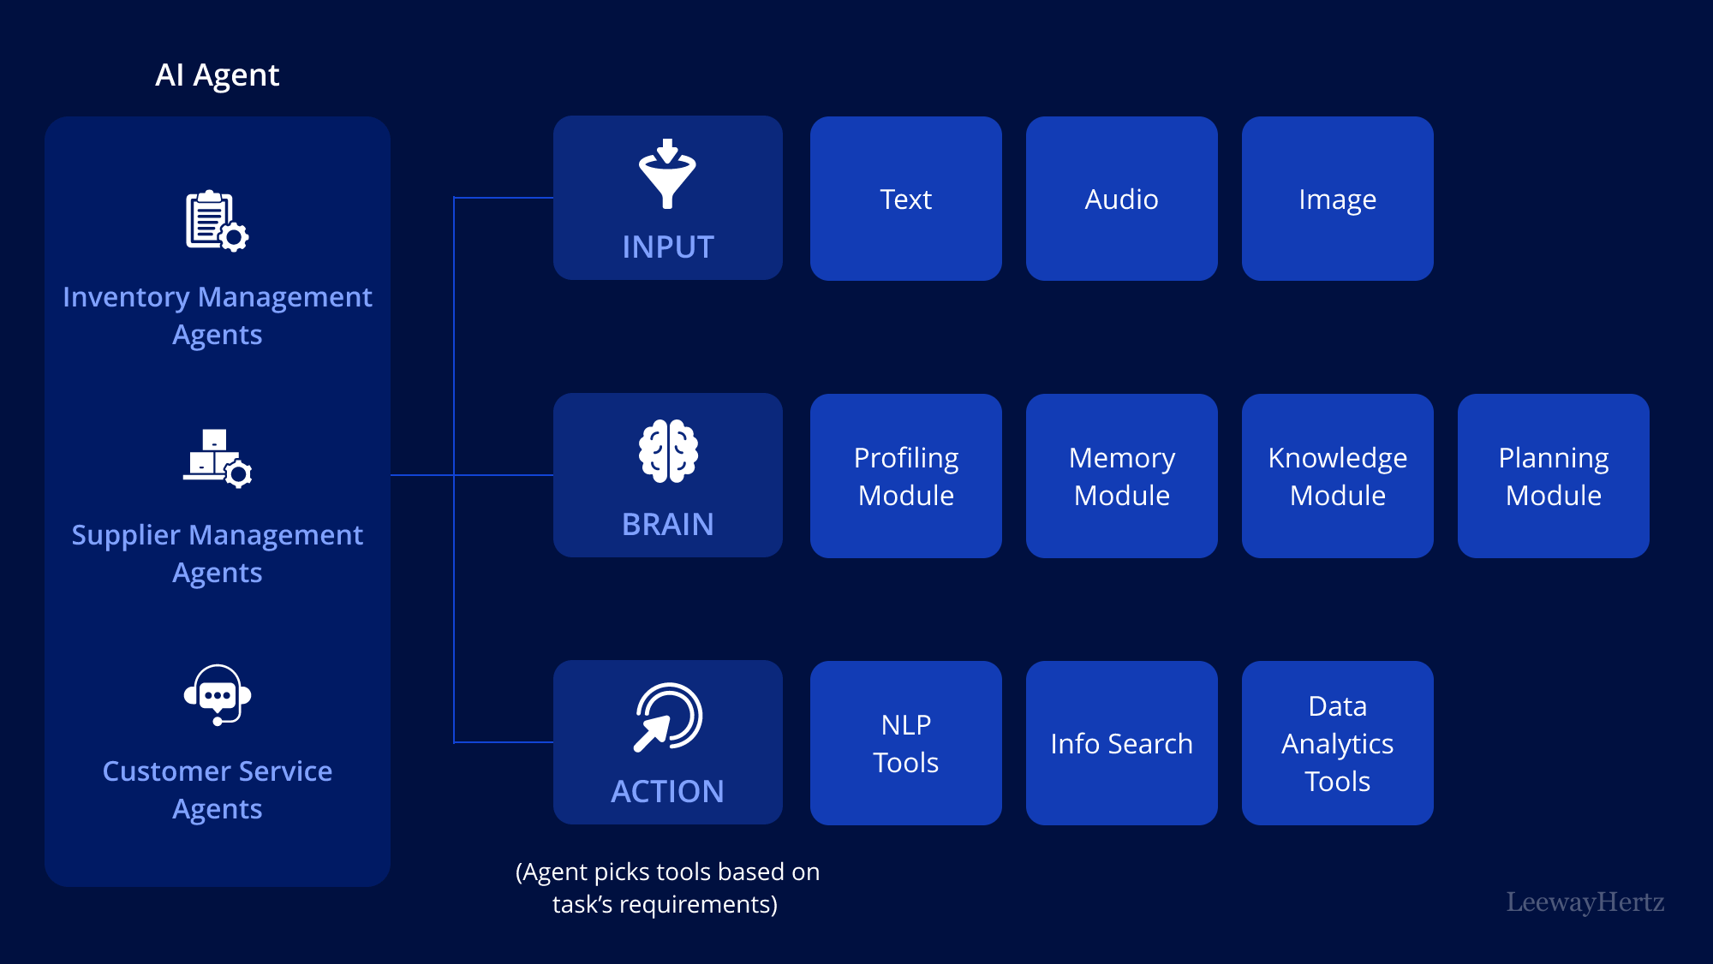
Source: https://www.leewayhertz.com/ai-agent-in-logistics-and-supply-chain/

Implementation Strategies and Best Practices

Designing Effective ReAct Agent Architectures
Successful ReAct agent implementation requires careful architecture design. The foundation lies in integrating three core components:
- The reasoning engine powered by LLMs
- The function calling system for tool integration
- The memory management system for context preservation
Design your reasoning engine with clear separation between observation, thought, and action phases. This structured approach ensures consistent decision-making processes. The architecture should support different reasoning strategies based on task complexity.
Function calling architecture requires careful design to support dynamic tool selection and integration. The system should maintain an inventory of available tools with clear specifications for:
- Input parameters
- Output formats
- Usage constraints
Memory management becomes critical for maintaining context across interactions. Balance the need for comprehensive context preservation with privacy considerations and computational efficiency. Consider hierarchical memory structures that maintain essential context while allowing for appropriate information decay over time.
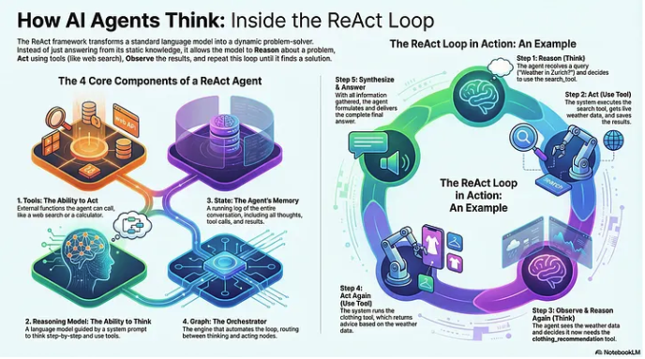
Source: https://medium.com/@tahirbalarabe2/build-react-ai-agents-with-langgraph-cb9d28cc6e20

Integration with Existing Systems and Workflows
Effective ReAct agent deployment requires seamless integration with existing business systems and workflows. The integration strategy should consider both technical compatibility and organizational change management.
Technical integration involves developing robust APIs and data exchange mechanisms. The agents should authenticate securely. They should access relevant data sources. They should perform authorized actions within existing security frameworks.
Workflow integration requires careful analysis of current business processes. Identify optimal touchpoints for agent intervention. Rather than replacing entire workflows, consider augmenting existing processes with intelligent decision support and automated task execution.
Implement gradual rollout strategies that allow teams to adapt progressively. Begin with non-critical tasks and simple use cases. Build confidence and understanding before expanding to more complex applications. Provide comprehensive training and support to help users interact effectively with ReAct agents.
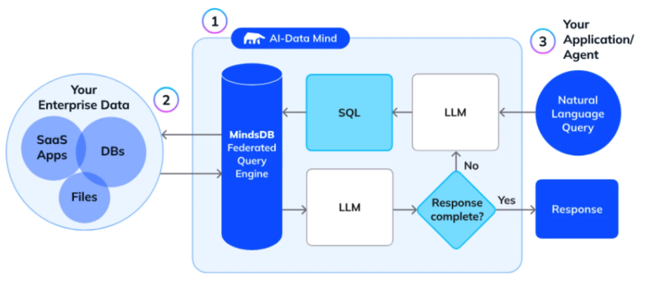
Source: https://mindsdb.com/blog/building-ai-agents-with-your-enterprise-data-a-developers-guide

Performance Optimization and Monitoring Strategies
Performance optimization for ReAct agents requires continuous monitoring and refinement. Track:
- Response time
- Accuracy
- Resource utilization
- User satisfaction
Establish comprehensive metrics and monitoring systems to track agent performance across various dimensions.
Response time optimization involves balancing reasoning depth with the need for timely results. Implement adaptive reasoning strategies that adjust analysis depth based on task urgency, complexity, and quality requirements.
Accuracy monitoring requires systematic evaluation of agent outputs against expected results and user feedback. Implement continuous feedback mechanisms. Allow users to rate agent performance. Provide specific input on decision quality. Use this feedback to refine prompting strategies, tool selection algorithms, and reasoning frameworks.
Resource utilization monitoring helps optimize computational efficiency and cost management. Track:
- LLM token usage
- Function calling frequency
- Memory consumption
Identify optimization opportunities. Implement usage thresholds and cost controls to prevent runaway resource consumption while maintaining service quality.

Future Outlook: The Evolution of AI Agent Technology

Emerging Trends in Reasoning and Acting Frameworks
The field of ReAct agents continues to evolve rapidly. Emerging trends point toward:
- More sophisticated reasoning capabilities
- Enhanced multi-modal integration
- Improved collaborative functionality
Advanced reasoning frameworks are incorporating more sophisticated logical structures. These include formal reasoning systems, probabilistic inference, and causal analysis. These enhancements enable agents to handle complex problem domains like scientific research, legal analysis, and strategic planning.
Multi-modal reasoning represents a significant frontier. Agents will integrate information from text, images, audio, and video sources. This opens new applications in multimedia content analysis, visual problem-solving, and complex data interpretation.
Collaborative reasoning frameworks enable multiple ReAct agents to work together on complex tasks. They share insights. They divide responsibilities. They coordinate actions. This approach tackles problems that exceed individual agent capabilities.

Integration with Advanced AI Technologies
The future of ReAct agents involves deeper integration with emerging AI technologies:
- Computer vision
- Speech recognition
- Robotics
- Advanced neural architectures
Computer vision integration enables ReAct agents to analyze visual information. They understand spatial relationships. They generate responses based on visual context. This supports applications in quality control, visual inspection, creative design, and augmented reality interfaces.
Robotics integration represents a natural evolution. Reasoning capabilities will direct physical actions in real-world environments. This promises applications in manufacturing, healthcare, domestic assistance, and exploration scenarios.
Advanced neural architectures will improve performance and capabilities while reducing computational requirements and costs. These improvements will make sophisticated reasoning capabilities more accessible to organizations of all sizes.

Implications for Business and Society
The widespread adoption of ReAct agents will have profound implications for business operations, workforce development, and societal structures.
Business implications include fundamental changes in how organizations approach problem-solving, decision-making, and task execution. ReAct agents will enable smaller organizations to access sophisticated analytical capabilities previously available only to large enterprises.
Workforce implications involve the evolution of job roles toward higher-level strategic thinking, creative problem-solving, and human-agent collaboration. Workers will need to develop skills in:
- Agent interaction
- Prompt engineering
- Result evaluation
Focus will shift to uniquely human capabilities like emotional intelligence, ethical reasoning, and creative innovation.
Societal implications encompass broader questions about AI governance, accountability, and benefit distribution. The transparency of ReAct agents' reasoning processes provides better foundations for AI explainability and accountability. But questions remain about intellectual property, decision authority, and liability in automated systems.

Frequently Asked Questions

What is the main difference between ReAct agents and automation agents?
The primary difference lies in decision-making approach. ReAct agents use sophisticated reasoning frameworks powered by LLMs to think through problems before acting. Automation agents follow predefined workflows without deliberation. ReAct agents adapt to new situations and handle complex, multi-step tasks through dynamic problem-solving. Automation agents execute static rule-based sequences.

How do LLMs enhance ReAct agent capabilities?
Large language models serve as the cognitive engine for ReAct agents. They enable natural language understanding, contextual interpretation, and sophisticated reasoning. LLMs allow ReAct agents to process nuanced human instructions, maintain conversational context, generate explanations for their actions, and adapt their responses based on complex situational analysis.

Do ReAct agents learn from their mistakes?
Yes. ReAct agents incorporate self-correction mechanisms. They identify errors, analyze failure modes, and implement alternative strategies on their own. While they don't retain information between sessions for privacy reasons, they learn and adapt within individual task sequences. They improve their approach based on feedback and intermediate results.

What are the best use cases for implementing ReAct agents?
ReAct agents excel in scenarios requiring complex reasoning, adaptability, and multi-step problem-solving. Optimal use cases include:
- Customer service automation
- Research and data analysis
- Content creation
- Business process management
- Applications where traditional automation fails due to complexity or variability
They're valuable for tasks that benefit from transparent decision-making and explainable AI capabilities.

How do ReAct agents handle tool integration compared to automation agents?
ReAct agents use dynamic function calling to select and combine tools based on task requirements and contextual analysis. They adapt their tool usage strategy throughout execution. They discover novel tool combinations. They handle errors by switching to alternative approaches. Automation agents use predetermined tool sequences. They don't deviate from established patterns or adapt to changing circumstances.

What are the computational requirements for running ReAct agents?
ReAct agents require more computational resources than traditional automation agents due to their LLM-powered reasoning capabilities. Resource requirements include:
- Sufficient processing power for language model inference
- Memory for context management
- Network connectivity for tool integration
Cloud-based LLM services and optimization techniques make ReAct agents accessible to organizations of various sizes.

Reflections
ReAct agents represent a shift toward more intelligent, adaptable AI systems. Their sophisticated reasoning frameworks, powered by large language models, enable dynamic decision-making. They surpass traditional automation agents in complexity, flexibility, and effectiveness.
The key advantages of ReAct agents position them as transformative tools for modern business operations:
- Chain-of-thought reasoning
- Context awareness
- Self-correction capabilities
- Explainable AI
They handle ambiguous instructions. They adapt to changing circumstances. They provide transparent decision-making processes. These capabilities address critical limitations of conventional automation systems while opening new possibilities for human-AI collaboration.
Understanding the distinctions between ReAct agents and automation agents becomes crucial for making informed implementation decisions. The choice depends on your specific use case requirements, complexity levels, and the need for adaptive intelligence versus predictable automation. While automation agents remain valuable for routine, well-defined tasks, ReAct agents unlock new capabilities for handling complex, dynamic challenges.
The future of AI agent technology points toward even more sophisticated reasoning capabilities, enhanced multi-modal integration, and collaborative frameworks. Organizations that invest in understanding and implementing ReAct agent technology today will be better positioned to leverage these advanced capabilities as they continue to evolve.
By embracing the reasoning and acting framework that defines ReAct agents, you unlock new levels of automation intelligence. You improve decision-making processes. You create more responsive, adaptable AI systems that augment human capabilities rather than simply replace repetitive tasks. The transition from rigid automation to intelligent reasoning represents a fundamental evolution in how we deploy artificial intelligence in real-world applications.

Did you enjoy this post? Here are some other AI Agents posts you might have missed:
KV Caching and Speculative Decoding

A deep dive into Quantization: Key to Open Source LLM Deployments

Agents are here and they are staying

How Agents Think

Memory – The Agent’s Brain

Agentic RAG Ecosystem

Multimodal Agents

Scaling Agents: Architectures with Google ADK, A2A, and MCP

Fully Functional Agent Loop

Ready to take it to the next level?
Check out my AI Agents for Enterprise course on Maven and be a part of something bigger and join hundreds of builders to develop enterprise level agents.

Use this link to get $201 OFF!
You’re receiving this email because you’re part of our mailing list—and you’ve attended, registered for, or been invited to our MAVEN events. These emails are the only way to reliably receive updates from us. We don’t spam or sell your information. If you prefer not to receive our messages, simply unsubscribe below and we’ll respect your wishes.

